**Q 28. Program to add two string – create a class named marriage, create a program to add the surname of groom with the bride’s name.**

class Marriage

{

String name;

String surname;

Marriage(String n, String s)

{

name=n;

surname=s;

}

static Marriage add(Marriage ob1, Marriage ob2)

{

return new Marriage(ob1.name, ob1.surname+ob2.surname );

}

}

public class Eg

{

public static void main(String []args)

{

Marriage ob1=new Marriage("Aishwarya", "Rai");

Marriage ob2= new Marriage("Abhishek", " Bacchan");

Marriage ob3=Marriage.add(ob1, ob2);

System.out.println(ob3.name+" "+ob3.surname);

}

}

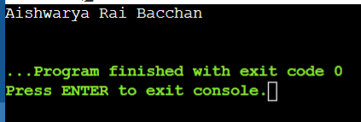

**Q 29. Program to get a strings length.**

public class Main  
{  
public static void main(String[] args) {  
 String greet = "Hello! World";  
 System.out.println("String: " +greet);  
   
 int length = greet.length();  
 System.out.println("Length: " +length);  
}  
}

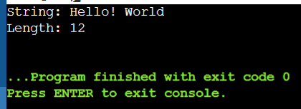

**Q 30. Program to print strings.**

public class Main

{

public static void main(String[]args)

{

String first = "Java";

String second = "Python";

System.out.println(first);

System.out.println(second);

}

}

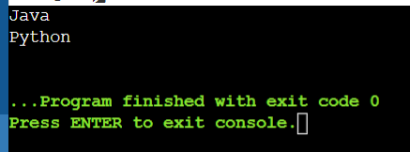

**Q 31. Program to print whether a string is empty or not.**

class Empty

{

public static void main(String []args)

{

String s = "Hello!";

Boolean b = s.isEmpty();

System.out.println(b);

}

}

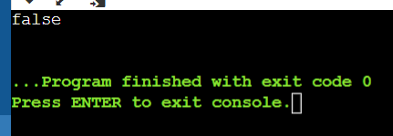

**Q 32. Program to print any character from a string and to convert the whole string into upper case and lowercase.**

class Main

{

public static void main(String[]ars)

{

String s = "Hello";

System.out.println(s.charAt(3));

System.out.println(s.toUpperCase());

System.out.println(s.toLowerCase());

}

}

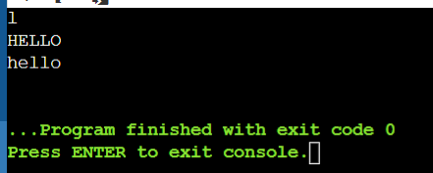

**Q 33. Program to input a string from the user and turn it to upper or lower case according to the user.**

import java.util.Scanner;

public class ChangeCase

{

public static void main(String[] args)

{

System.out.println("Enter String ; ");

Scanner sc = new Scanner(System.in);

String s = sc.nextLine();

System.out.println("Enter choice:\n 0 for lowercase\n 1 for Uppercase");

int i = sc.nextInt();

switch(i)

{

case 0:

System.out.println(s.toLowerCase());

break;

case 1:

System.out.println(s.toUpperCase());

break;

default :

System.out.println("Error!");

}

}

}

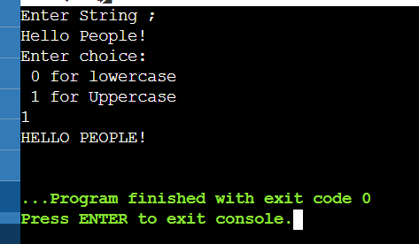

**34. Program to check whether the given strings are equal or not.**

class Comparable

{

public static void main(String[]args)

{

String n1 = "Java Programming";

String n2 = "Java Programming";

String n3 = "Python Programming";

boolean result = n1.equals(n2);

System.out.println("Strings 1 and 2 are equal."+result);

boolean result1 = n2.equals(n3);

System.out.println("Strings 2 and 3 are equal: "+result1);

}

}

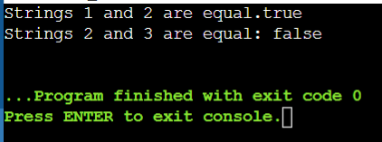

**35. Program to count the number of times ‘e’ occurs in the word ‘umbrella’.**

class Ans{

public static void main(String[]args)

{

String a = "Umbrella";

int count=0;

for(int i=0; i<a.length(); i++)

{

if(a.charAt(i) == 'e');

count++;

break;

}

System.out.println("count: "+count);

}

}

